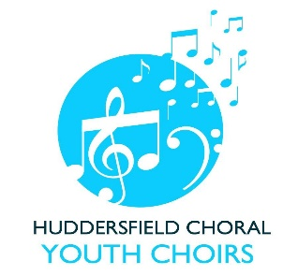
HUDDERSFIELD CHORAL YOUTH CHOIRS 2023-2024 SUBSCRIPTION

PLEASE ENSURE YOU COMPLETE THE FULL NAME OF THE CHOIR MEMBER & CHOOSE ONE OF THE FOLLOWING OPTIONS (circle or delete as appropriate).
FULL NAME OF CHOIR MEMBER ____________________________________________

ONE PAYMENT OF £105 FOR FULL YEAR SUBSCRIPTION PAYABLE BY END OCTOBER | YES/NO

OR
3 INSTALMENTS OF £40 EACH, PAYABLE BY END SEPTEMBER, END JANUARY AND END APRIL | YES/NO

PLEASE LET US KNOW WHETHER YOU WISH TO PAY BY CASH OR CHEQUE AT A REHEARSAL OR BY A DIRECT BANK TRANSFER. Lloyds Bank refer to this as Faster Payment.

CASH/CHEQUE AT REHEARSAL | YES/NO
DIRECT BANK TRANSFER /LLOYDS BANK FASTER PAYMENT | YES/NO

If you wish to pay by direct bank transfer our BANK DETAILS are as follows:
Lloyds Bank, Huddersfield Choral Society Junior Choirs
Account number 00120484
Sort Code 30-94-43
Please give “HCYC Subscription” as bank reference.

Please note we would not usually accept a mixture of payment methods throughout the year. If you elect to pay by instalment and direct through your bank, please let us know if you need to cancel the bank arrangement and continue your payments by cash or cheque.

Please Gift Aid your subscription if possible. See a Committee Member for a Gift Aid declaration form if necessary.
PLEASE COMPLETE THIS FORM AND RETURN EITHER BY EMAIL OR AT REHEARSAL

