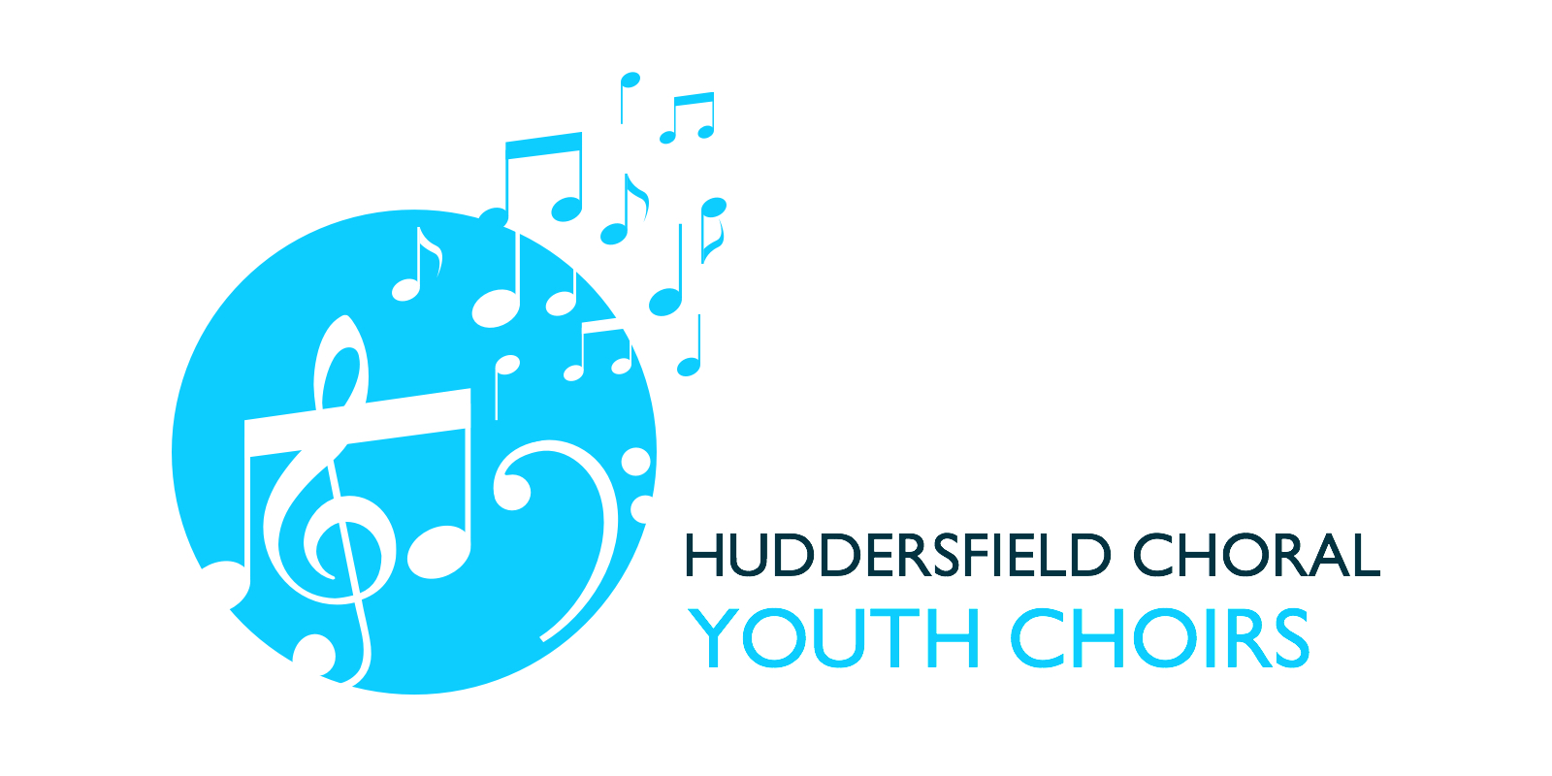
CONCERT PLANNING SCHEDULE – Autumn Term 2023-2024

PLEASE COMPLETE AND RETURN ASAP

Any Queries, please text Nicola on 07880813770 or email hcsyouthchoirs@gmail.com

NAME............................................................................................

(Circle one) Young Voices / Youth Choir

DATE | PERFORMANCES | FURTHER DETAILS… | I CAN ATTEND  YES/NO
Thursday 19th or Friday 20th October | HOLMFIRTH MUSIC FESTIVAL  Young Voice Only | Venue: Holmfirth Civic Hall  Time: evening tbc  The exact date & time will be confirmed nearer the time when released by the festival organisers
Tuesday 24th October | EXTRA REHEARSAL  (for the below event)  Vocalise only | This is a proposed rehearsal with the Choral Society  Full details tbc
Saturday 4th November | MONTEVERDI VESPERS  Vocalise Only | As guests of Huddersfield Choral Society  Time: evening tba
Sunday 3rd December | CHRISTMAS CONCERT | Holy Trinity Church  3pm
Thursday 7th December | EXTRA REHEARSAL | Huddersfield Town Hall  Time evening tbc  This extra rehearsal is in preparation for the following evening’s concert
Friday 8th December | HUDDERSFIELD CHORAL CHRISTMAS CONCERT | Huddersfield Town Hall  Times evening tbc

As the season progresses there may be other performances added which we will advise you of as soon as we are aware.

